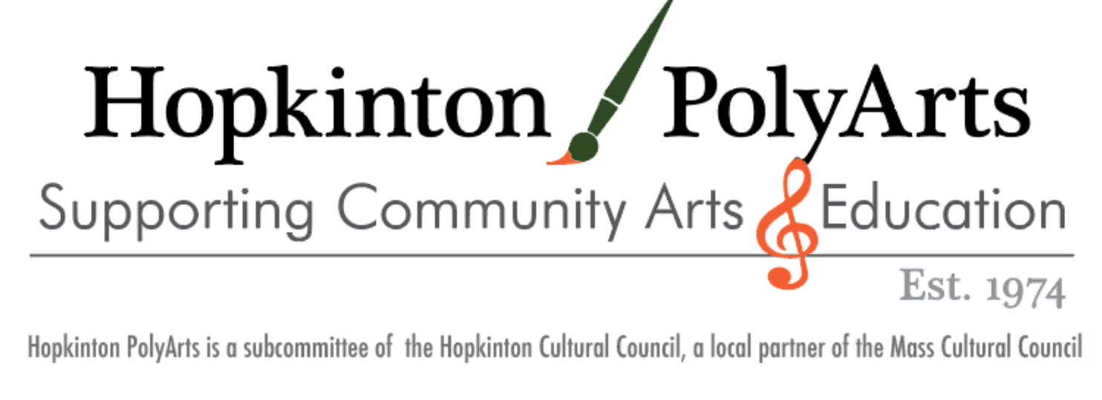

**2025 Annual Hopkinton Polyarts Festival**

**50th Anniversary Show!**

**Saturday, September 6, 2025**

**Hopkinton Town Common 10:00 am – 4:00 pm**

We invite you to apply for our annual Polyarts Festival! This event features more than 75 artists from throughout New England. The money raised benefits local cultural, historical, and educational programs including scholarships for students entering the visual or performing arts.

Polyarts began in 1974 as a demonstration of various arts and crafts to showcase the talents of the local community. Since then it has grown into a day-long event with professional artisans, performing artists, and community groups participating throughout the day. Polyarts is a family-friendly day with something for everyone - food, music, arts, and community!

To be considered for Polyarts, please complete and submit the following application package by **May 1, 2025 to Hopkinton Polyarts, P.O. Box 724, Hopkinton, MA 01748**. The application is also available online at: [Hopkinton Polyarts Fair](https://cozzens.net/polyarts/)

1. Completed application form. **Products offered for sale at Polyarts MUST be made by the artisan.**
2. Photos of your work, and of your booth set up: A maximum of 4 photos of your craft including one of your booth set-up. Samples, websites, e-mailed photos will not be accepted. Photos will **NOT** be returned. Remember, these photos represent your work in a competitive show, we strongly recommend that you print on quality paper sized 4x6 or larger (please no digital images). Without photos you will not be considered for our event. **You must list your name, business name and price range of merchandise on the back of the photos.**
3. Check payable to Hopkinton Polyarts.

**The Polyarts Committee will jury all application and decisions will be *emailed* on or before June 1.**

**NOTES:**

**NO REFUNDS AFTER ACCEPTANCE**: Polyarts collects no commission and does not charge a jury fee. Your only commitment is the space fee. If you are not accepted, your check will be returned.

**POLYARTS IS RAIN OR SHINE – THERE IS NO RAIN DATE FOR THIS EVENT**

**FOOD VENDORS**: Once accepted, you must obtain food permits from the Hopkinton Board of Health (Ph. #508-497-9725) and abide by their regulations. Polyarts has no control over the decision of the Board of Health regarding the granting or revoking of temporary food service permits. **Paperwork MUST be completed BY AUGUST 1st.**

**2025 Annual Hopkinton Polyarts Festival**

**Saturday, September 6, 2025**

**Hopkinton Town Common 10:00 am – 4:00 pm**

**Please print clearly:**

Name: ____________________________________________________________________________________________ Business Name:_____________________________________________________________________________________ Phone/Cell:_________________________________ Email:__________________________________________________ Address:___________________________________________________________________________________________ Sales & Use Tax Registration Number (**Mandatory**) ________________________________________________________

Make/Model of Car: ________________________________ License Plate: ____________________________________

Do you require ADA access and/or an end booth due to accessibility needs: ____________________________________

Have you had a booth at Polyarts before? _______ If so, approximately how many years have you participated? _____

**Type of Application:**

________$ 100 Artist Vendor for 10 x 10 canopy space (must supply own canopy and weights. No stakes)

________$ 70 Food Vendor (must pay additional $ 50 for permit from Hopkinton Board of Health)

________$ 35 Non-Profit (must be Hopkinton non-profit)

________$0 for Town Committee

**Please check the category/categories that apply to your artisan products:**

_____ ART: Acrylic, Decorative Painting, Oils, Pastels, Watercolors, Wooden Items

_____ FABRIC: Adult and Children Clothing, Handbags, Knitting and Crocheting

_____ FOOD

_____ GLASS AND METALS: Ceramics, Fused/Stained/Painted Glass, Pewter, Pottery, Silver

_____ JEWELRY

_____ LEATHER: Bags, Belts, Accessories

_____ NATURAL ITEMS: Bee Products, Lotions, Natural make-up, Skincare, Soaps

_____ PAPER: Cards, Photography, Stationery

_____ TOYS: Dolls, Doll Clothes, Stuffed Animals, etc., Wooden Toys

_____ WOOD

_____ OTHER (Please describe): ______________________________________________________________________

Description/Details:_________________________________________________________________________________

**By submitting this application, I hereby certify I will offer for sale at Polyarts *only items made by me*.** I agree to abide by the Show Rules and Regulations as outlined above by the Polyarts Committee. I understand that if I have been accepted to exhibit at Polyarts there are no refunds. Furthermore, I hereby release the Polyarts Committee solely as a group and the Town of Hopkinton from all liability for personal injury and for damage/loss of property due to fire, theft, accident or other unforeseen circumstances.

________I understand and agree to abide by the rules of this show as set forth on this application.

Signature:_________________________________________________Date:____________________________________

Return this form by May 1, 2025, with your signed check, and up to four photos of your craft. Photos will NOT be returned. **The Polyarts Committee will jury all applicants and notifications will go out on or before June 1, 2025.**

**PLEASE MAIL APPLICATIONS TO: Hopkinton Polyarts, PO Box 724, Hopkinton MA 01748.**